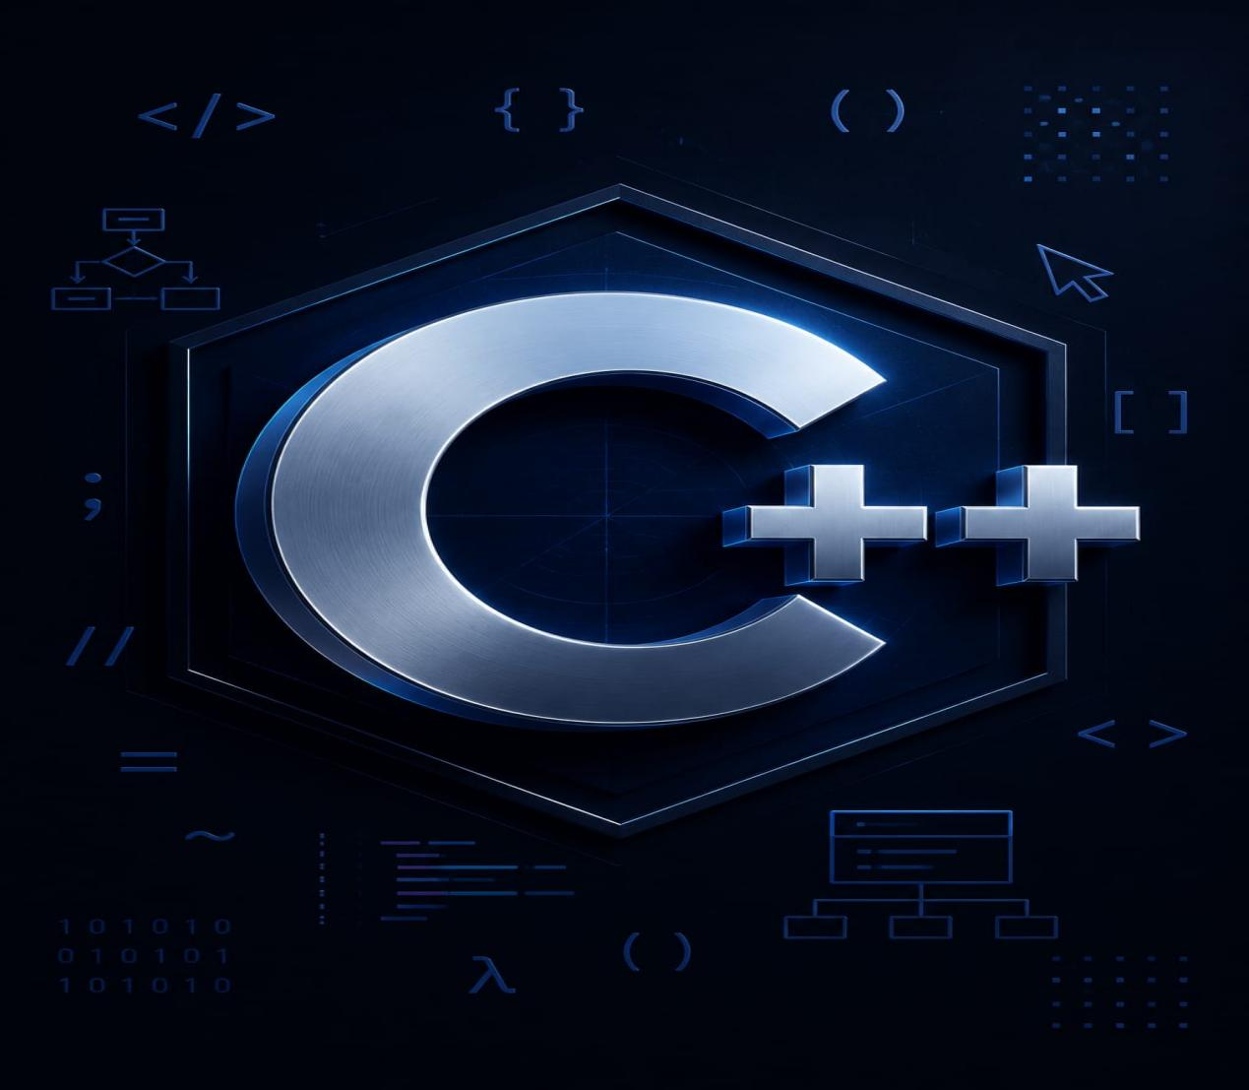

①Fundamentals
②Object Oriented Programming
③Data Structures & Algorithms

By Jawad Jammoul

